**QUIZ NO# 1**

**Name:**

**Section:**

**Registration No:**

1. **List the names of the layers in OSI Model in order and compare graphically with the TCP/IP Suite**

**QUIZ NO# 2**

**Name:**

**Section:**

**Registration No:**

1. **Contrast between the Ethernet Switch and Router**

|  |  |  |
| --- | --- | --- |
| **S.No** | **Switch** | **Router** |
| **1** |  |  |
| **2** |  |  |

**QUIZ NO# 3**

**Name:**

**Section:**

**Registration No:**

**List the DHCP messages in sequence and provide the info as per the following table**

|  |  |  |
| --- | --- | --- |
| **Message name** | **Whether Unicast, Multicast, or Broadcast** | **Reason** |
|  |  |  |
|  |  |  |
|  |  |  |
|  |  |  |

**QUIZ NO# 4**

**Name:**

**Section:**

**Registration No:**

**Which two statements are correct about private IPv4 addresses? (Choose two.)**



1. **Private IPv4 addresses are assigned to devices within an organization’s intranet (internal network).**



1. **Internet routers will typically forward any packet with a destination address that is a private IPv4 address.**



1. **172.99.1.1 is a private IPv4 address.**



1. **Any organization (home, school, office, company) can use the 10.0.0.0/8 address.**

**QUIZ NO# 5**

**Name:**

**Section:**

**Registration No:**

**My computer ip setting are the following:**

**IPv4 Address. . . . . . . . : 10.137.20.13**

**Subnet Mask . . . . . . . . . . . : 255.255.252.0**

**What is the broadcast and network address of this network ?**

**QUIZ NO# 6**

**Name:**

**Section:**

**Registration No:**

**In this activity, you are given the number of hosts that are needed. Determine the subnet mask that would support the number of hosts as specified. Enter your answers in binary, decimal, and prefix notation format in the fields provided**.



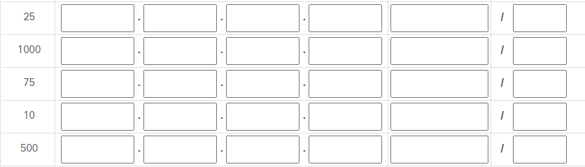

**P18-14.** Explain how DHCP can be used when the size of the block assigned to an organization is less than the number of hosts in the organization.

DHCP dynamically assigns IP addresses to those who need them and unassign when their operation is complete.

**P18-15.** Compare NAT and DHCP. Both can solve the problem of a shortage of

addresses in an organization, but by using different strategies.

NAT utilizes a private network and a limited number of private addresses for local communication. DHCP dynamically assigns addresses as it sees fit.

**dd734ff8**

**e95ba82b**